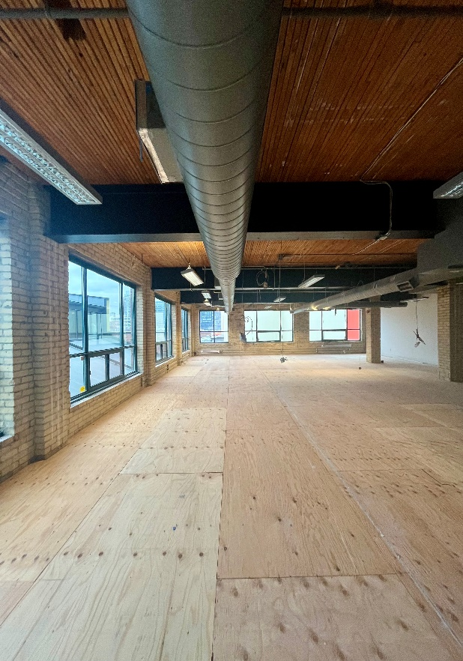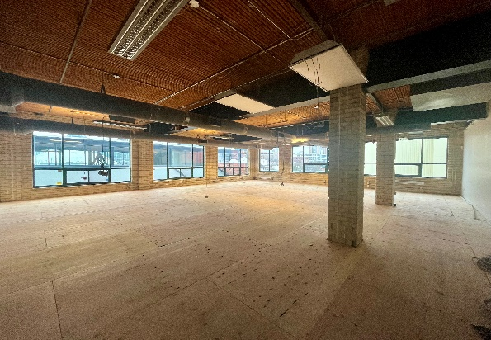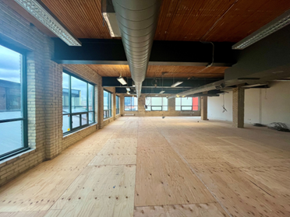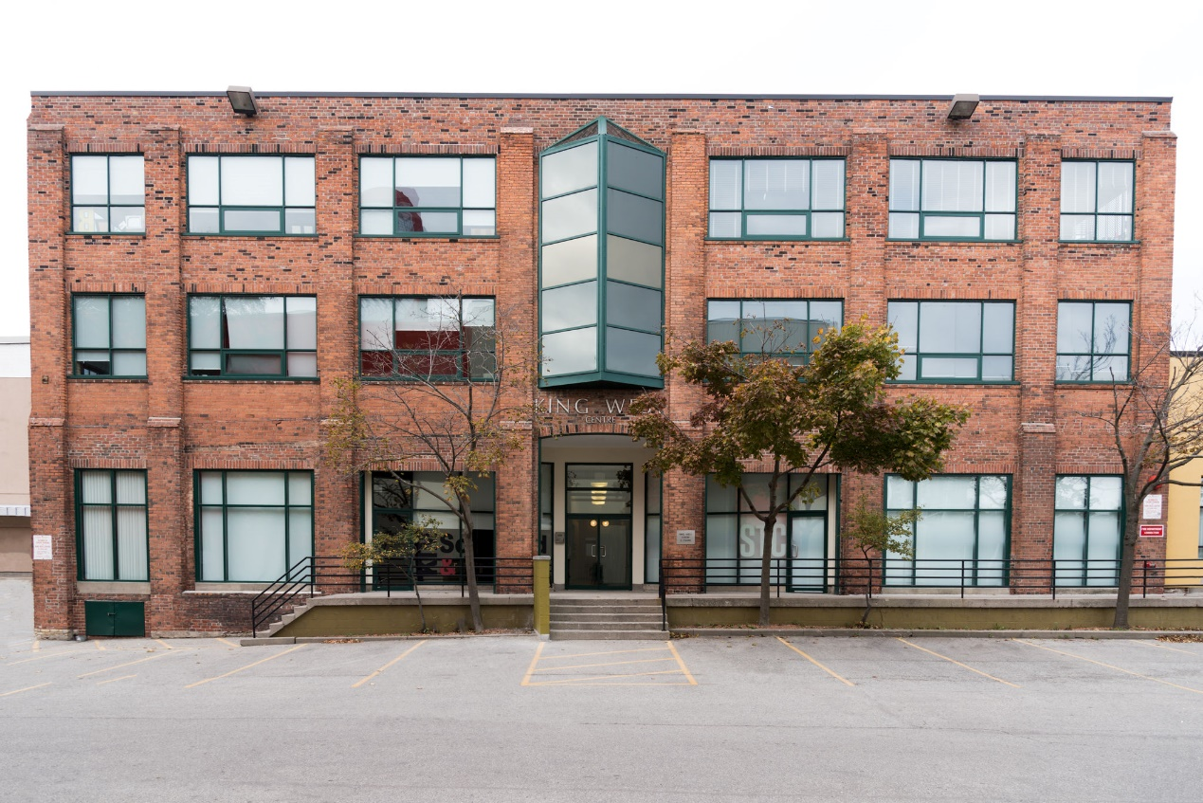

**DETAILS**

Availability: Suite 2P203

Size: 2,645 sq ft

TMI: $16.25 (including hydro)

Rent: Contact us

Term: Flexible

**HIGHLIGHTS**

Brick and beam corner space.

New lights, flooring and kitchenette to be installed by landlord

Open plan ready for tenant improvements

High ceilings and large operable windows

Reserved parking onsite

Multiple transit points nearby

*Liberty Village* - a hip, contemporary neighborhood with roots in Toronto’s industrial past

***2 Pardee Avenue The King West Centre***

***FOR LEASE***

**Honor Sewell**

**401-119 Spadina Avenue, Toronto, ON, M5V 2L1**

**P: 416.593.6420 | F: 416.593.6375 | www.wtfgroup.com**