

***FULL FLOOR FOR LEASE!***



**Honor Sewell**

**401-119 Spadina Avenue, Toronto, ON, M5V 2L1**

**P: 416.593.6420 | F: 416.593.6375 | www.wtfgroup.com**

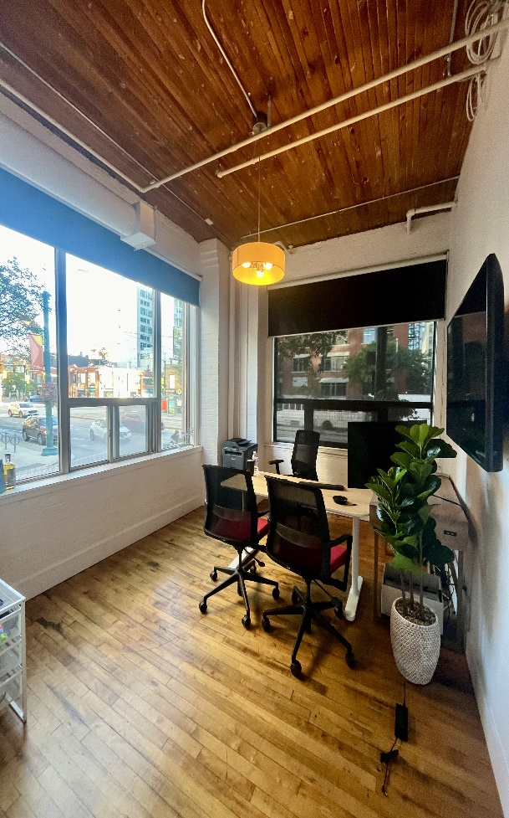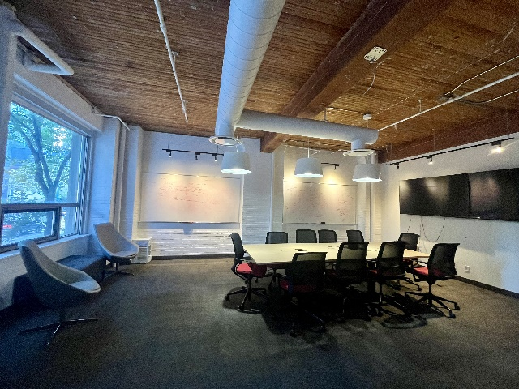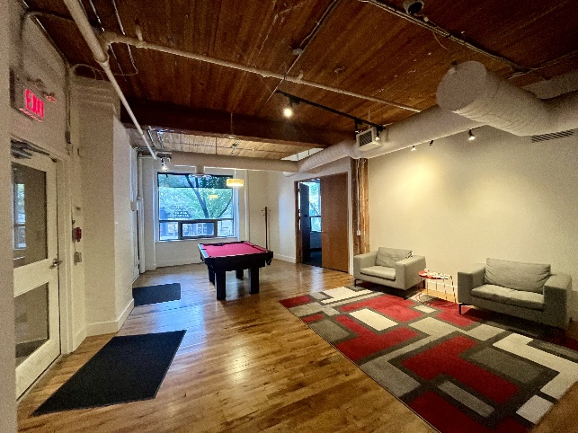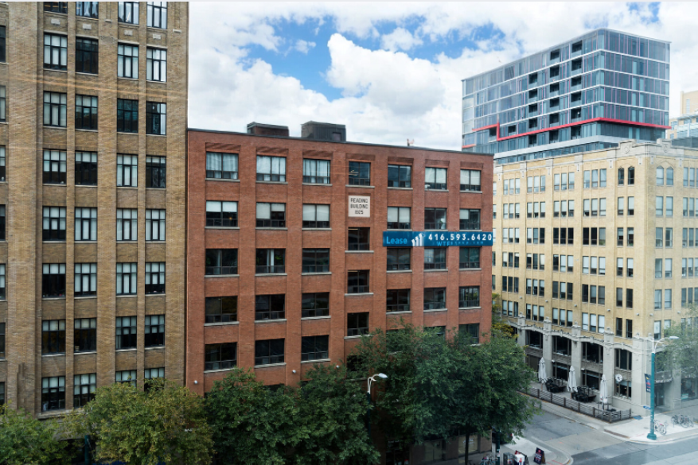

**DETAILS**

Availability: Suite 100

Size: 7,411 sq ft

TMI: $16.25 psf (plus hydro)

Net Rent: Contact us

Term: Flexible

**HIGHLIGHTS**

Full floor available in a classic post & beam building.

Bright and airy with high

ceilings and large windows

Direct fright elevator access

**Built out w/ 6 offices,boardroom, reception, kitchenette and ensuite washrooms**. Landlord

will provide further leasehold improvements to a qualified tenant.

Walkthrough [**VIEW HERE**](https://drive.google.com/file/d/1dbS2-FU0_s2Sq9LKPui5I70ejtn46DWh/view?usp=sharing)

Tenants are invited to enjoy the rooftop patio at 130 Spadina

***116 SPADINA AVE.***

***The Reading Building***

