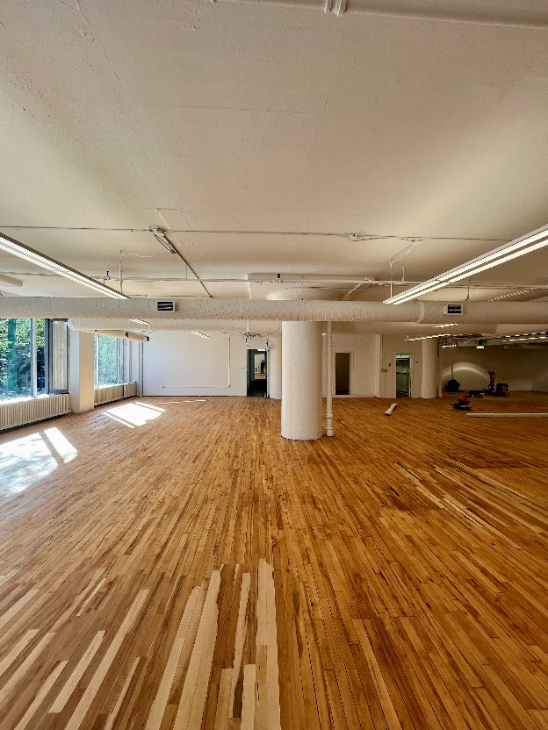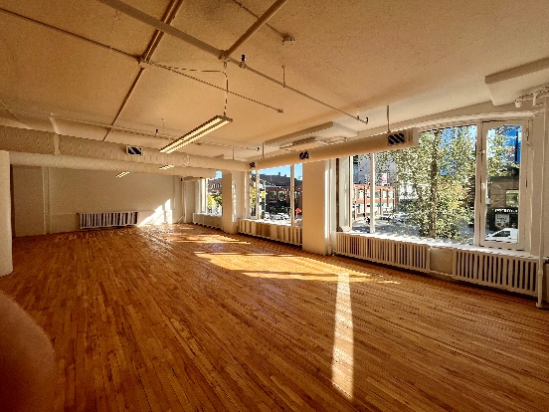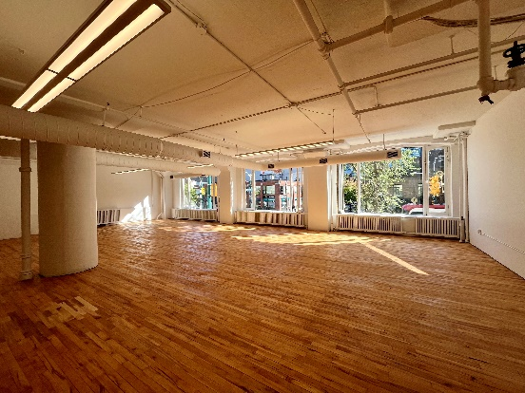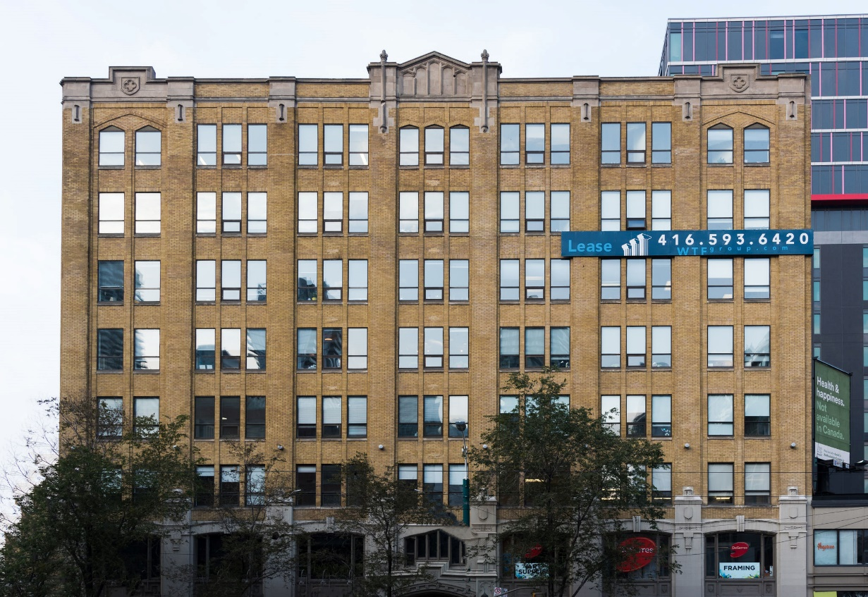

***130 SPADINA AVE.***

***The Fashion Building***

***FOR LEASE***

**DETAILS**

Availability: Suite 200

Size: **2,496 sq ft.**

TMI: $16.25 psf (plus hydro)

Rent: Contact us

Term: Flexible

**HIGHLIGHTS**

Ideal office or showroom space.

Large character windows over looking Spadina Ave.

Landlord will provide leasehold improvements to a qualified tenant.

Hardwood floors.

Direct fright access.

LRT at the doorstep.

Stunning rooftop terrace with wifi

**Honor Sewell**

**401-119 Spadina Avenue, Toronto, ON, M5V 2L1**

**P: 416.593.6420 | F: 416.593.6375 | www.wtfgroup.com**