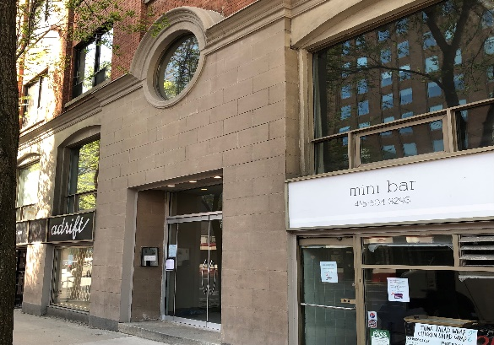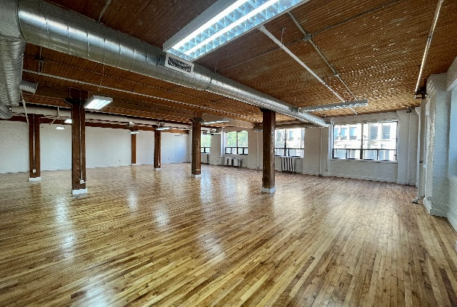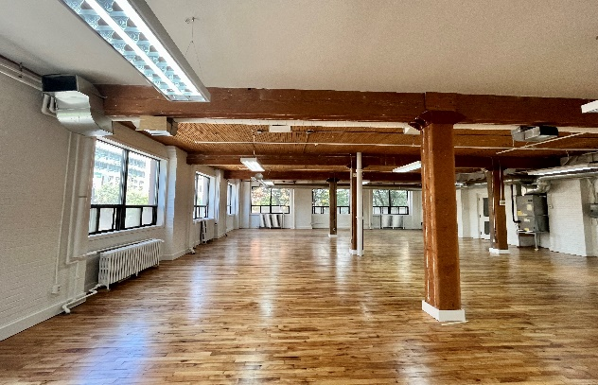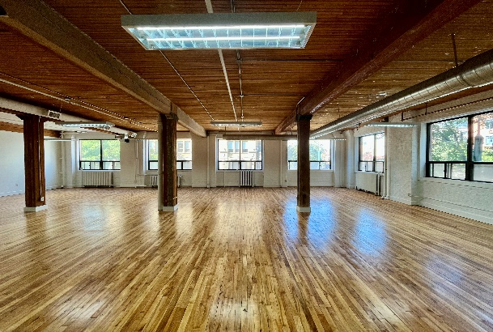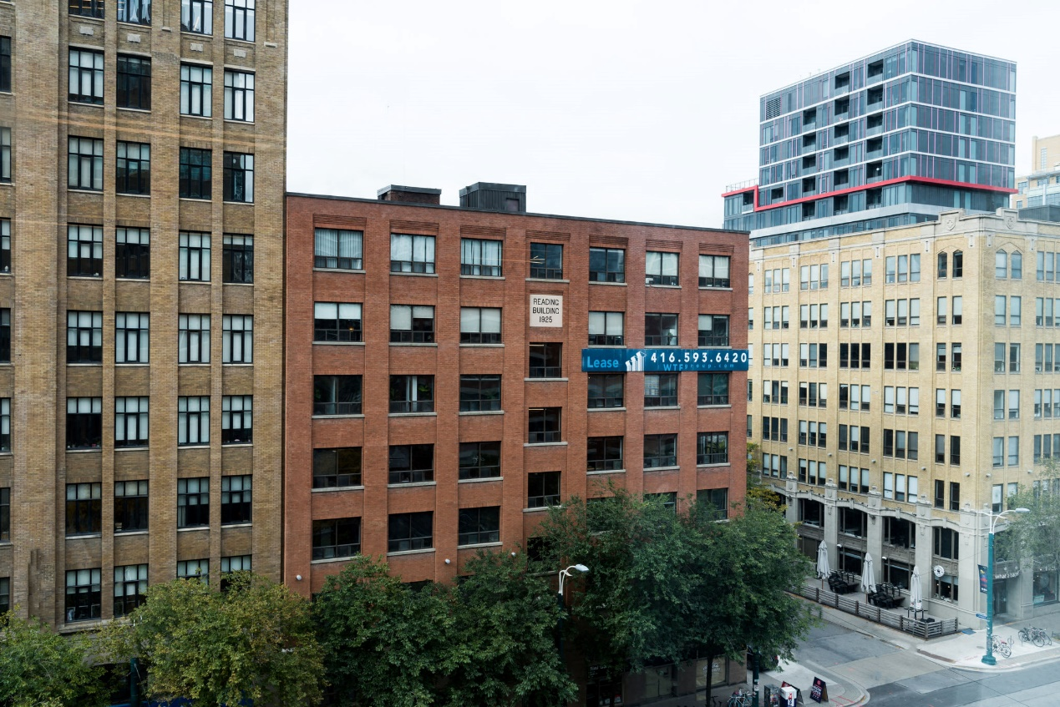

**DETAILS**

Availability: Suite 202

Size: 1,769 sq ft

TMI: $16.25 psf (plus hydro)

Net Rent: Contact us

Term: 3 - 5 years

**HIGHLIGHTS**

Beautiful light filled loft space

Open plan with kitchenette

Stunning post and beam architecture

Large operable windows

LRT at the doorstep

Tenants are invited to enjoy the rooftop patio at

130 Spadina

***FOR LEASE***

***116 SPADINA AVE.***

***The Reading Building***

**Honor Sewell**

**401-119 Spadina Avenue, Toronto, ON, M5V 2L1**

**P: 416.593.6420 | F: 416.593.6375 | www.wtfgroup.com**