

***FOR LEASE!***



**Honor Sewell**

**401-119 Spadina Avenue, Toronto, ON, M5V 2L1**

**P: 416.593.6420 | F: 416.593.6375 | www.wtfgroup.com**

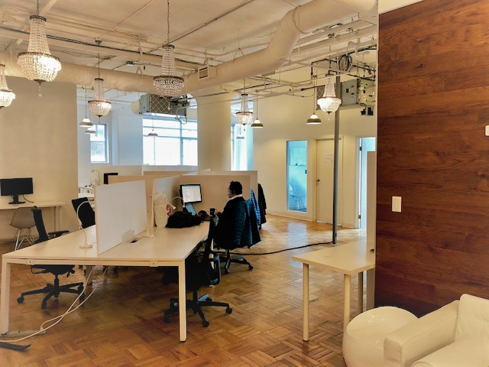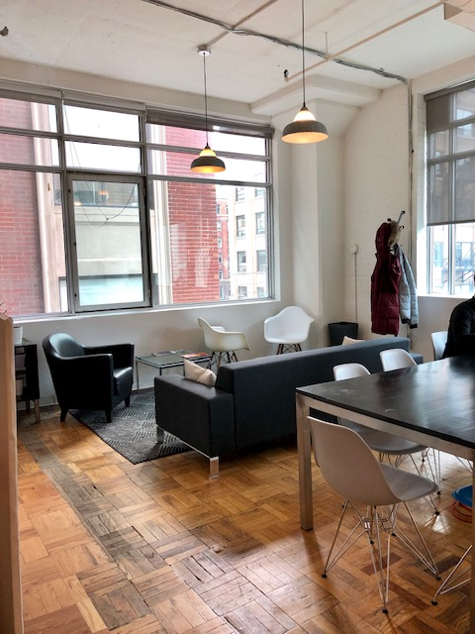

**DETAILS**

Availability: Suite 304

Size: 2,653 sq ft

TMI: $18.15 psf (including hydro)

Net Rent: Contact us

Term: 3 - 5

**HIGHLIGHTS**

Corner suite with large windows

Open space plus 3 offices, meeting room and kitchenette.

**Landlord will provide further leasehold improvements to a qualified tenant.**

11 foot ceilings

Gleaming wood floors and operable windows

Rooftop terrace with WIFI for tenant enjoyment

Multiple transit points nearby

***119 SPADINA AVE***

***The Balfour Building***