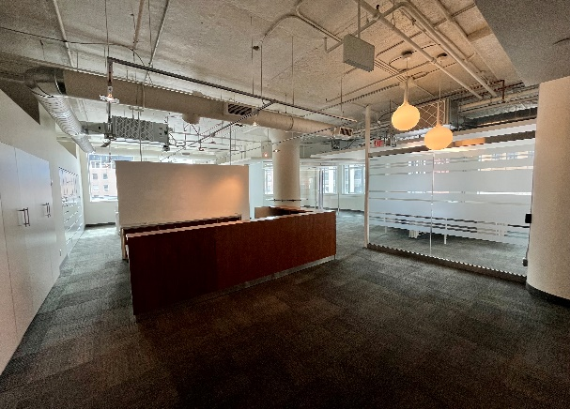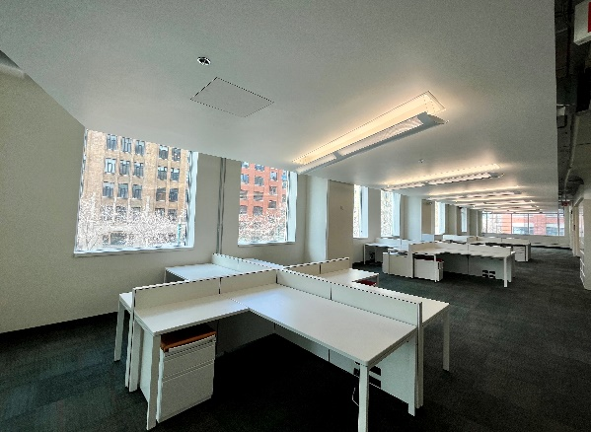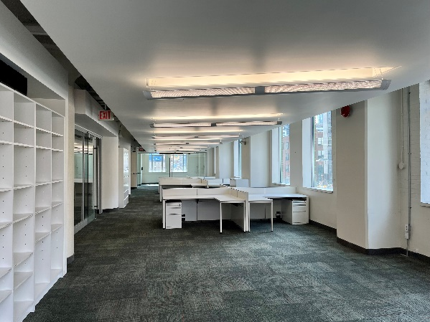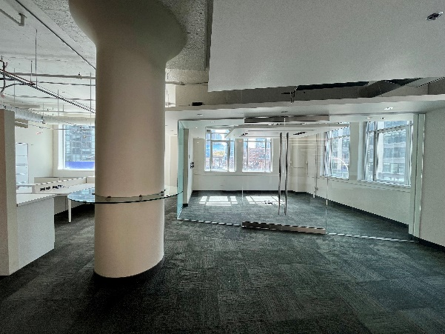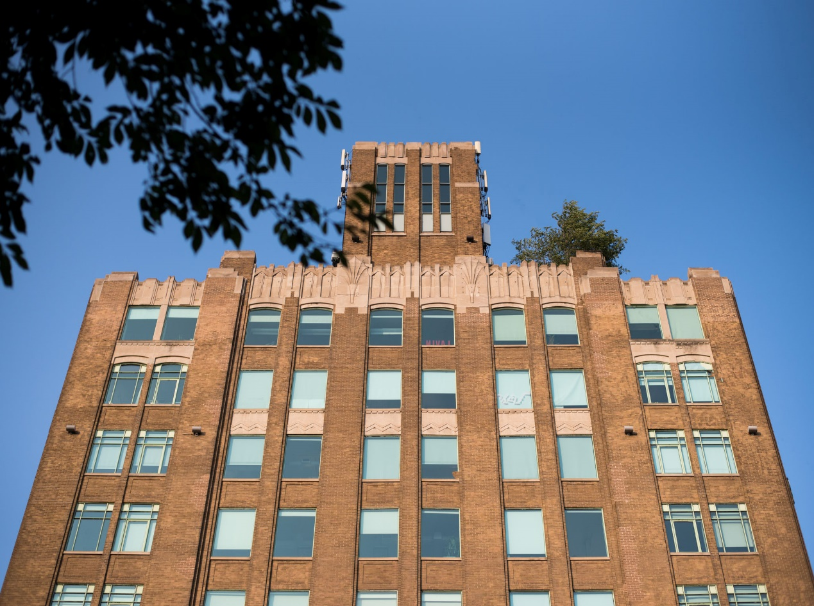

**DETAILS**

Availability: Suite 305

Size: 5,300 sq ft

TMI: $18.15 psf (including hydro)

Net Rent: Contact us

Term: 5 years

**HIGHLIGHTS**

Bright suite with south, west

and north facing windows

Great exposure with glass entrance direcly off elevator

Open plan for workstations

Glass boardroom, 3 offices

and kitchenette. Landlord will provide further leasehold improvements to a qualified tenant.

Rooftop terrace with WIFI for tenant enjoyment.

***FOR LEASE***



***119 SPADINA AVE***

***The Balfour Building***

**Honor Sewell**

**401-119 Spadina Avenue, Toronto, ON, M5V 2L1**

**P: 416.593.6420 | F: 416.593.6375 | www.wtfgroup.com**