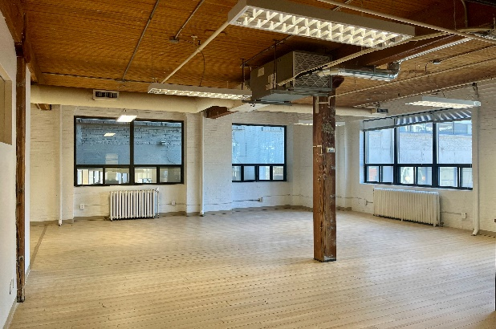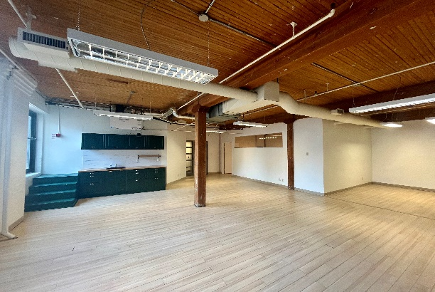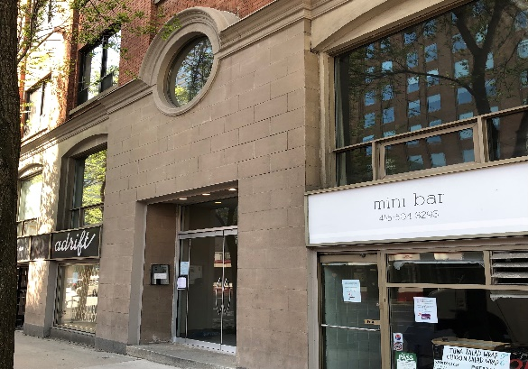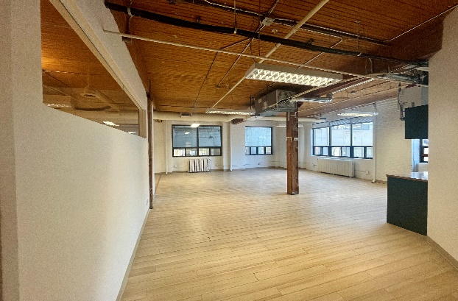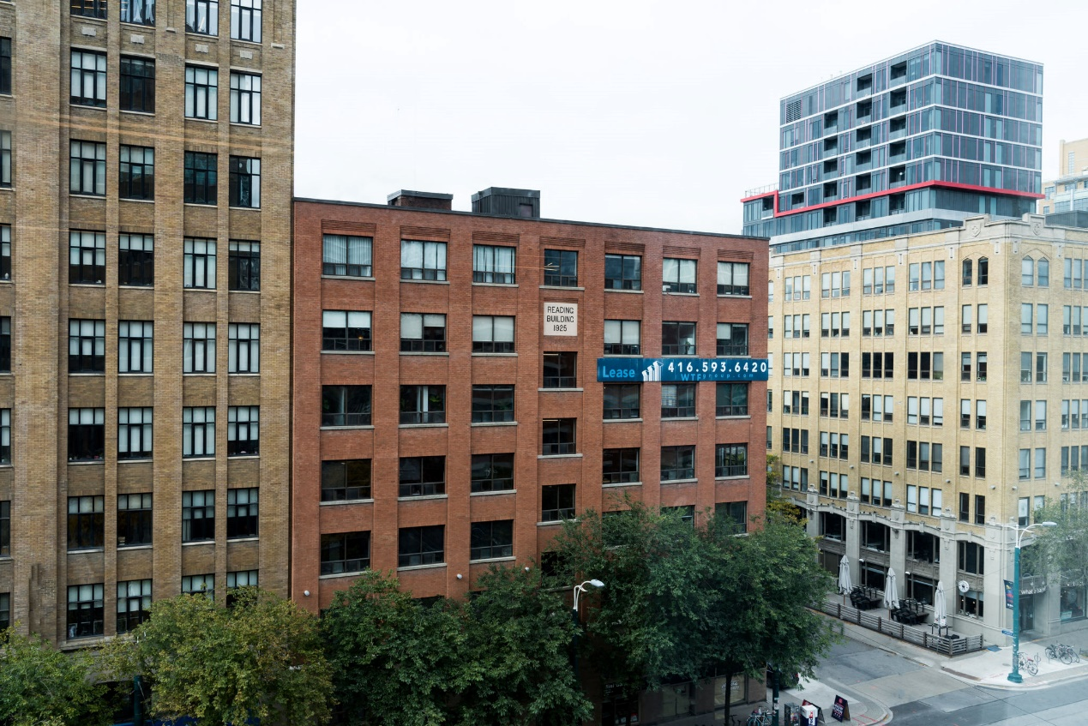

**DETAILS**

Availability: Suite 407

Size: 1,465 sq ft

TMI: $16.25 psf (plus hydro)

Net Rent: Contact us

Term: Flexible

**HIGHLIGHTS**

Open plan with meeting room and recently updated kitchenette

Classic post and beam suite

Large operable windows

High ceilings

Beautiful historic building

LRT at the doorstep

**Tenants are invited to enjoy the rooftop terrace at**

**130 Spadina** [**VIEW HERE**](https://my.matterport.com/show/?m=TvAAkNHsjHx)

***FOR LEASE***

***116 SPADINA AVE.***

***The Reading Building***

**Honor Sewell**

**401-119 Spadina Avenue, Toronto, ON, M5V 2L1**

**P: 416.593.6420 | F: 416.593.6375 | www.wtfgroup.com**