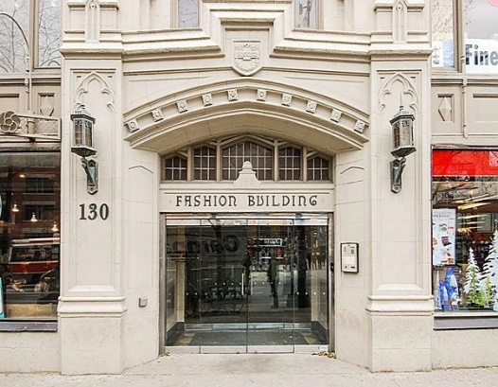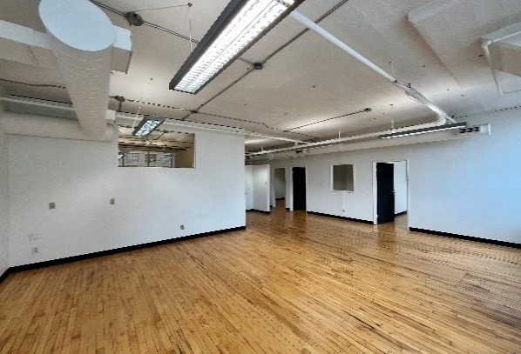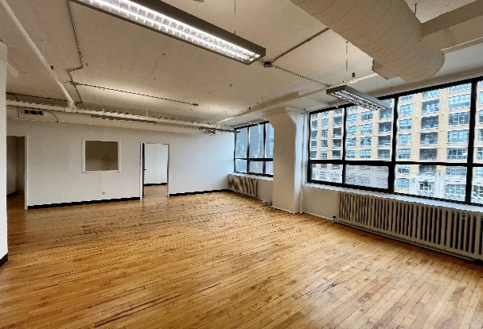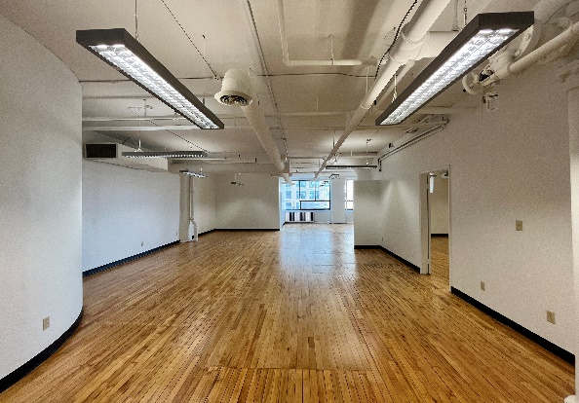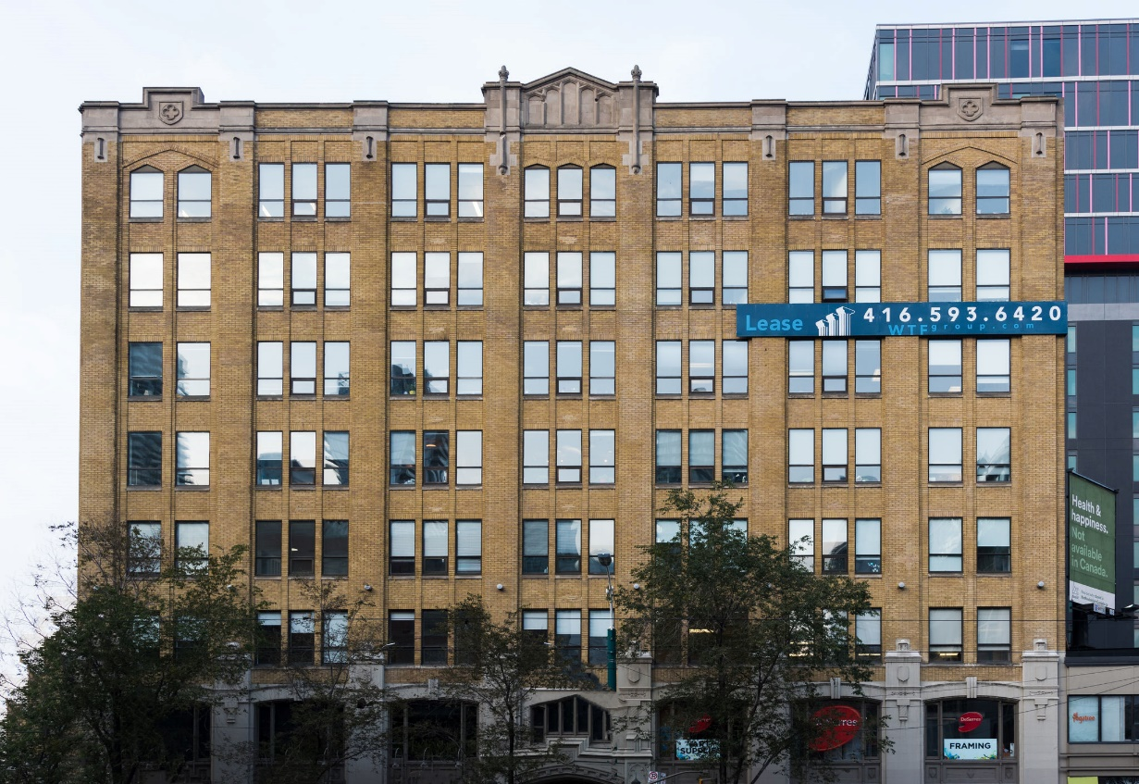

***FOR LEASE***

***130 SPADINA AVE.***

***The Fashion Building***

**DETAILS**

Availability: Suite 408

Size: 1,859 sq ft

TMI: $16.25 psf (plus hydro)

Net Rent: Contact us

Term: Flexible

**HIGHLIGHTS**

Ample open space for work stations

1 office, large boardroom and kitchenette. Landlord will provide further leasehold improvements to a qualified tenant.

Gleaming hardwood floor

Large operable windows

LRT at the doorstep

Great downtown location

Stunning rooftop terrace with wifi

**Honor Sewell**

**401-119 Spadina Avenue, Toronto, ON, M5V 2L1**

**P: 416.593.6420 | F: 416.593.6375 | www.wtfgroup.com**