

***HALF FLOOR FOR LEASE!***



**Honor Sewell**

**401-119 Spadina Avenue, Toronto, ON, M5V 2L1**

**P: 416.593.6420 | F: 416.593.6375 | www.wtfgroup.com**

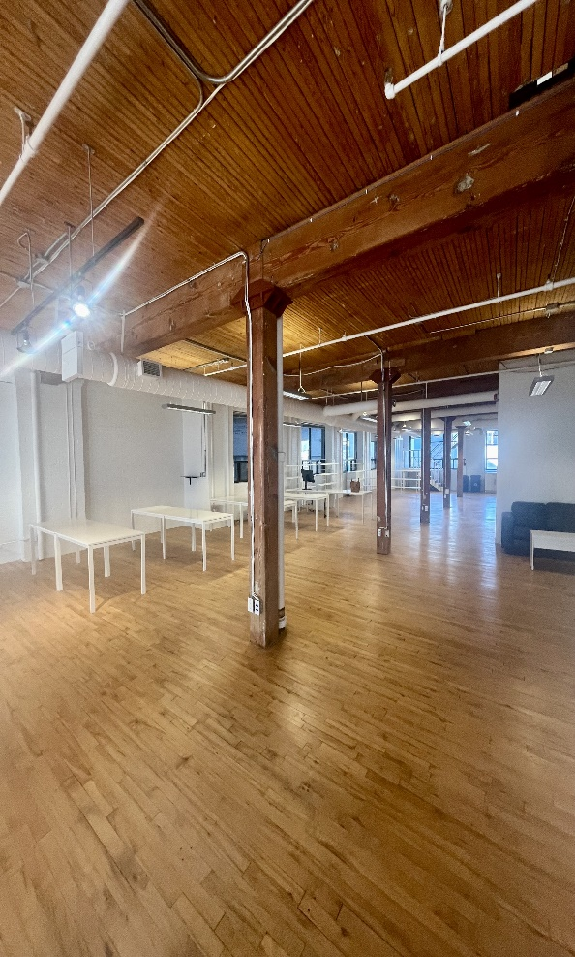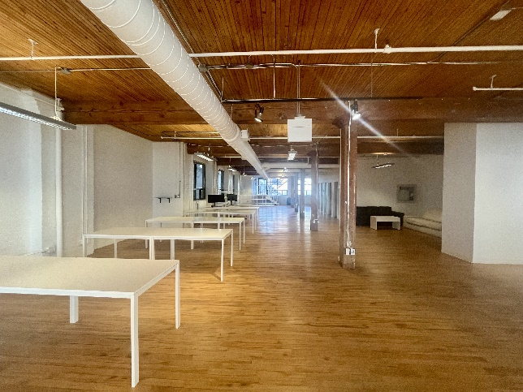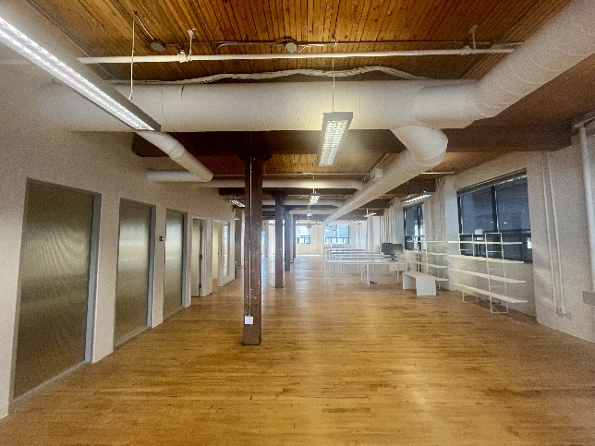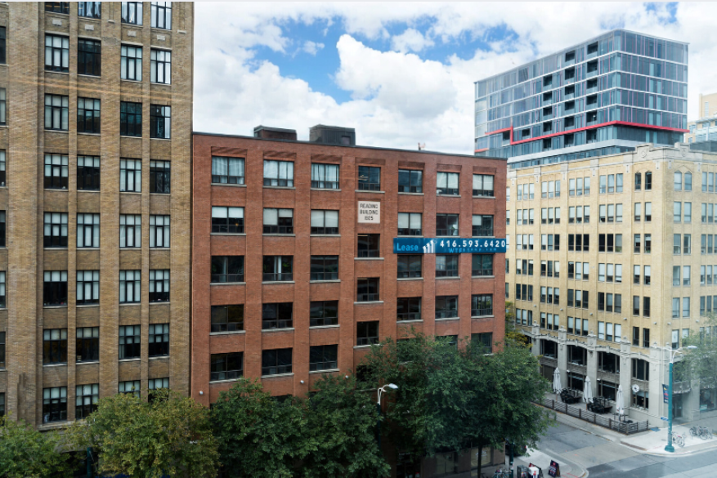

**DETAILS**

Availability: Suite 500

Size: 3,562 sq ft

TMI: $16.25 psf (plus hydro)

Net Rent: Contact us

Term: Flexible

**HIGHLIGHTS**

Half a floor available in a classic post & beam building.

Hardwood floors, high ceilings and large windows.

Direct fright elevator access

**Mainly open plan w/ 2 offices, boardroom, kitchenette, ensuite washrooms**. Landlord will provide further leasehold improvements

to a qualified tenant.

Walkthrough [**VIEW HERE**](https://drive.google.com/file/d/1GkqiEfhw04VNUjAMpEcBfijGxK1Qd6UJ/view?usp=sharing)

Tenants are invited to enjoy the rooftop patio at 130 Spadina

***116 SPADINA AVE.***

***The Reading Building***