

***FOR LEASE!***



**Honor Sewell**

**401-119 Spadina Avenue, Toronto, ON, M5V 2L1**

**P: 416.593.6420 | F: 416.593.6375 | www.wtfgroup.com**

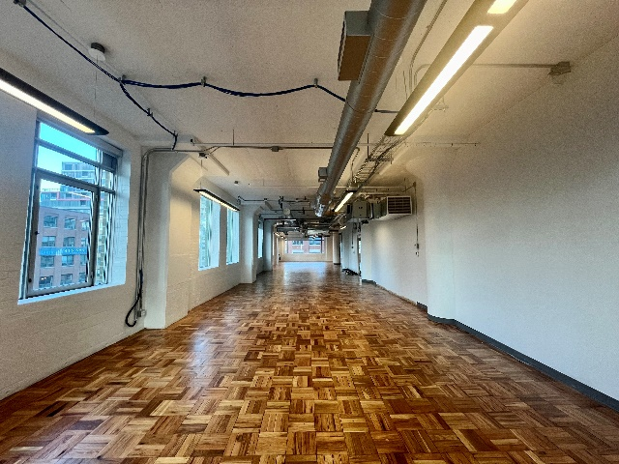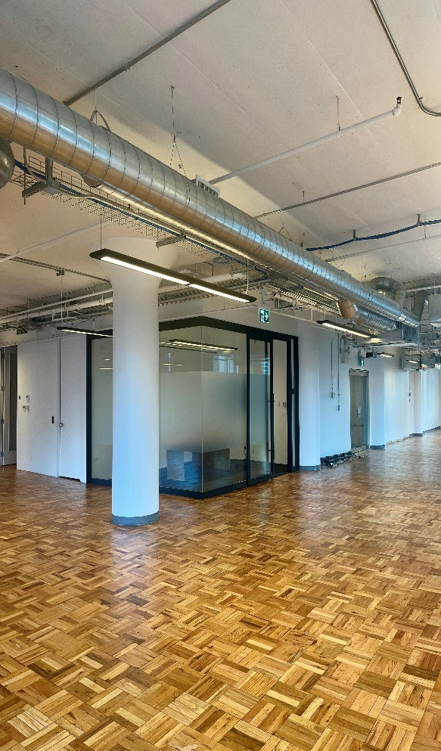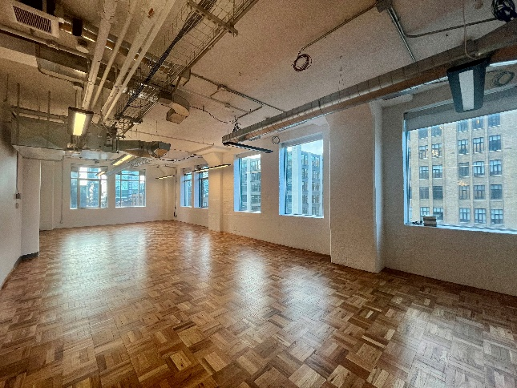

**DETAILS**

Availability: Suite 600

Size: 4,370 sq ft

TMI: $18.15 psf (including hydro)

Net Rent: Contact us

Term: 3 - 5

**HIGHLIGHTS**

Bright suite with south, west

and north facing windows

Mainly open plan with meeting room and kitchenette.

**Landlord will provide further leasehold improvements to a qualified tenant.**

11 foot ceilings

Gleaming wood floors and operable windows

Walkthrough [**VIEW HERE**](https://drive.google.com/file/d/1kFMyQwBoyfvJNZePotUIGk3C0yXjjd1Y/view?usp=drive_link)

Rooftop terrace with WIFI for tenant enjoyment

***119 SPADINA AVE***

***The Balfour Building***

