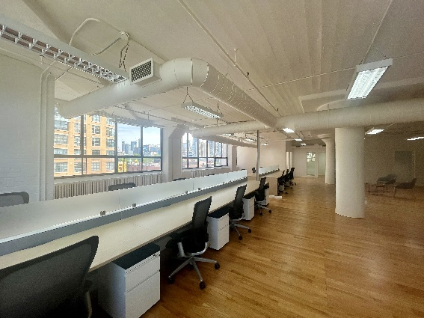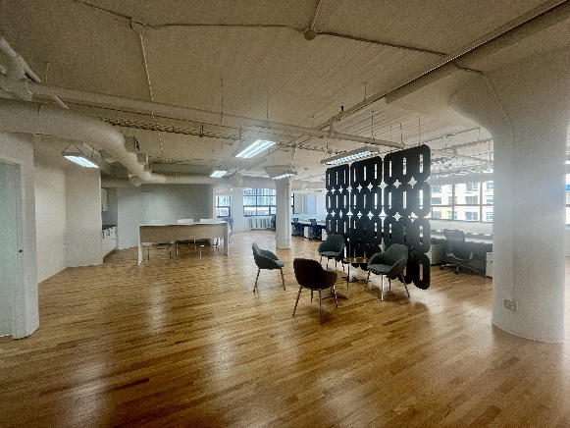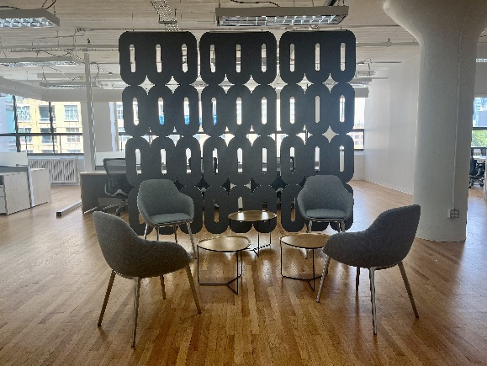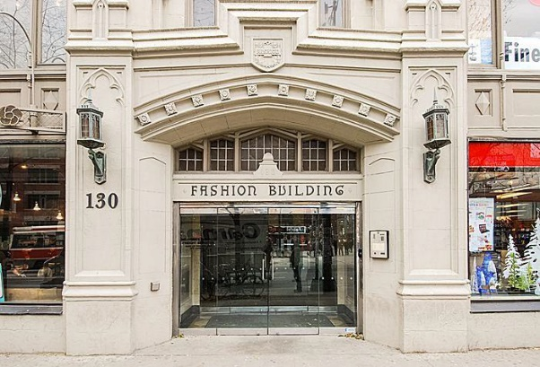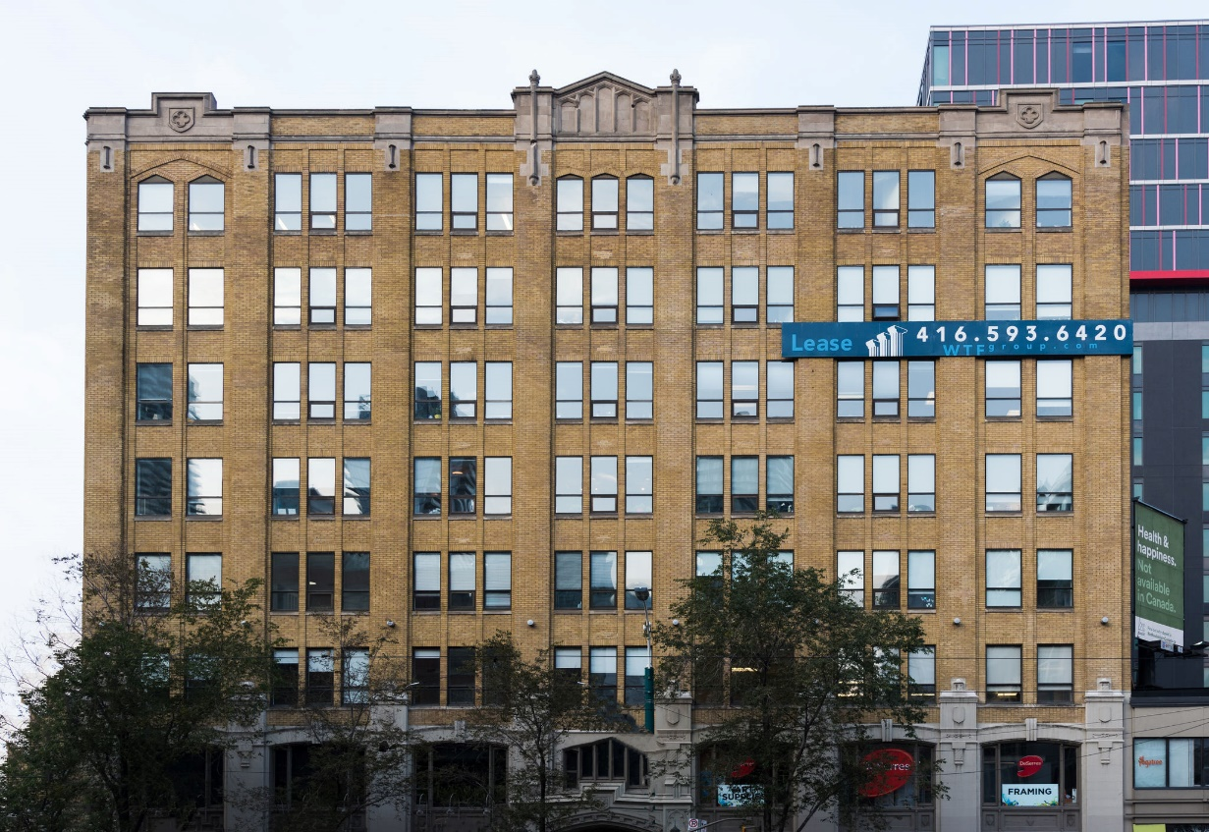

**DETAILS**

Availability: Suite 603

Size: **3,332 sq ft.**

TMI: $16.25 psf (plus hydro)

Rent: Contact us

Term: 3 – 5 years

**HIGHLIGHTS**

Fully furnished corner suite

Mainly open plan w/ 3 offices, boardroom server/storage and kitchenette

Hardwood floors

Large operable windows

LRT at the doorstep

Great downtown location

Walkthrough [**VIEW HERE**](https://drive.google.com/file/d/1G62Ytbq81waDmw8wWUdm-YsCzZVLSdd2/view?usp=sharing)

Stunning rooftop terrace with wifi

***130 SPADINA AVE.***

***The Fashion Building***

***FOR LEASE***

**Honor Sewell**

**401-119 Spadina Avenue, Toronto, ON, M5V 2L1**

**P: 416.593.6420 | F: 416.593.6375 | www.wtfgroup.com**