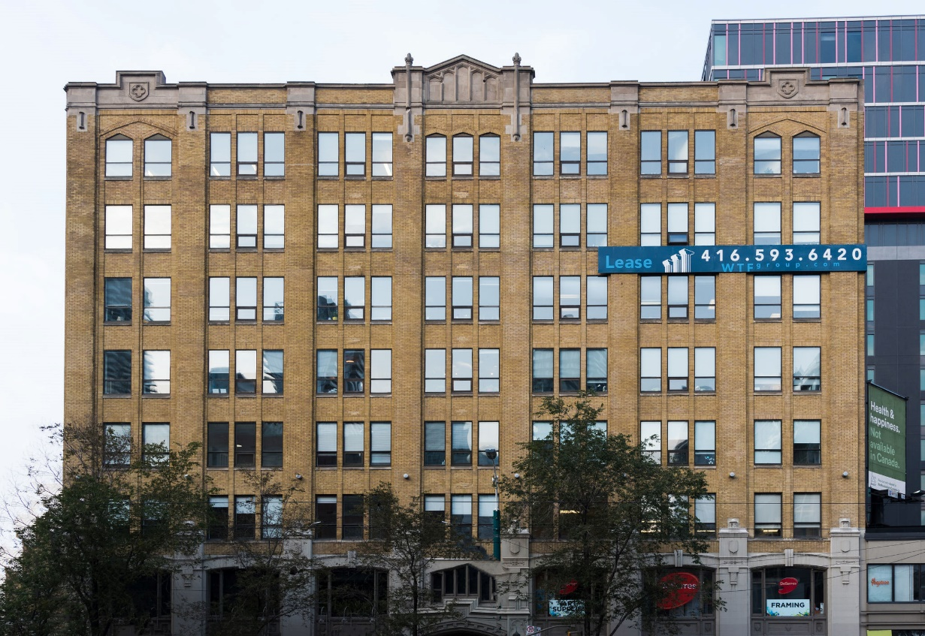

***130 SPADINA AVE.***

***FOR LEASE AT***

**DETAILS**

Availability: Suite 702

Size: 1,053 sq ft

Rent: Contact us

TMI: $16.25 psf (plus hydro)

Term: Flexible

**HIGHLIGHTS**

Corner suite with large operable windows

Bright open plan with meeting room/lounge and kitchenette

Hardwood floors

Beautiful historic property

LRT at the doorstep

Great downtown location

Stunning rooftop terrace with wifi

**Honor Sewell**

**401-119 Spadina Avenue, Toronto, ON, M5V 2L1**

**P: 416.593.6420 | F: 416.593.6375 | www.wtfgroup.com**



