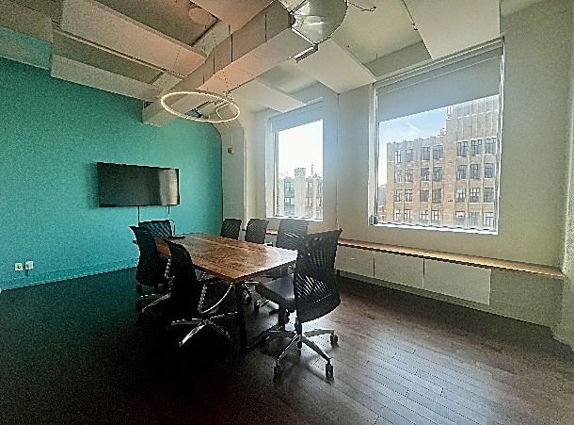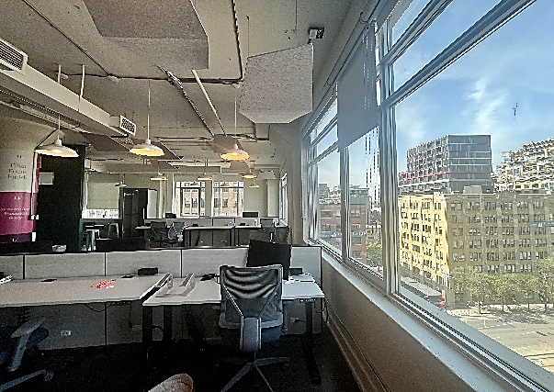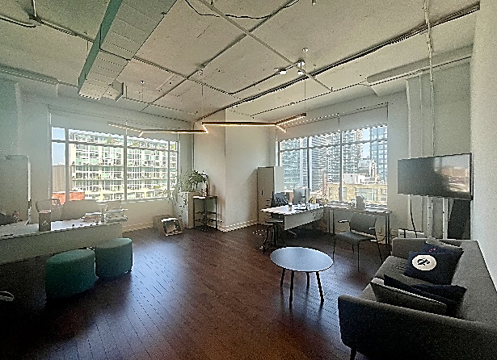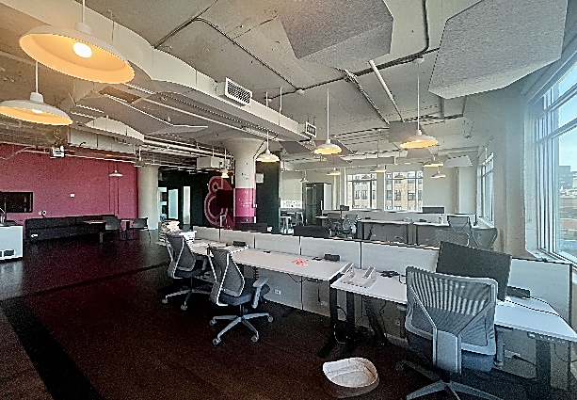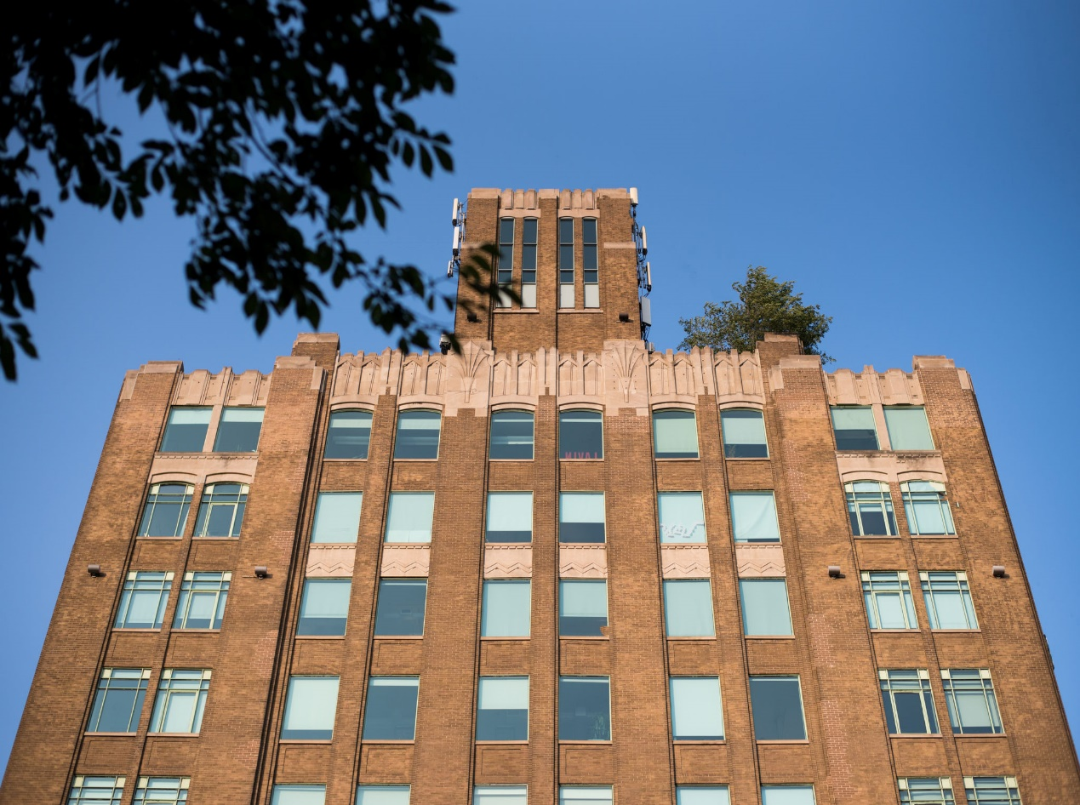

***FOR LEASE***



**DETAILS**

Availability: Suite 800

Size: 6,228 sq ft

TMI: $18.15 psf (including hydro)

Net Rent: Contact us

Term: 5 years

**HIGHLIGHTS**

Beautiful character space with updated, modern finishes

Fully Furnished

Multiple office/meeting rooms plus open space.

Bright and airy with large windows

11ft ceilings. Gleaming wood floors

Rooftop terrace with WIFI for tenant enjoyment

***119 SPADINA AVE***

***The Balfour Building***

**Honor Sewell**

**401-119 Spadina Avenue, Toronto, ON, M5V 2L1**

**P: 416.593.6420 | F: 416.593.6375 | www.wtfgroup.com**